Computer Network Laboratory



Student Name | Swapnil Birajdar
SRN No | 31231287
Roll No | 41
Program | AIDS
Year |   Third  Year
Division | A
Subject | Computer Network Laboratory
Assignment No | 1

Computer Network Laboratory

Assignment Number
-

01

Title : Ad-Hoc and Infrastructure Network

Problem Statement : Set up a small network of 2 to 4 computers using Switch. It includes installation of LAN Cards, Preparation of Cables, Assigning IP addresses and sharing C drive.

Write information IN word document related to following computer network terms with diagram.
- NIC Card
- Hub
- Switch
- Network Topology
- Crimping tool
- LAN tester
- Connector -RJ11, RJ45
- Twisted pair cable – Straight through cable & Cross Over cable

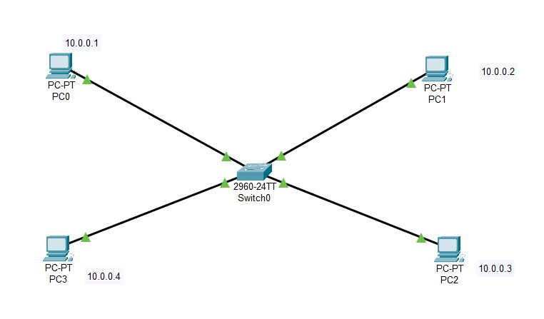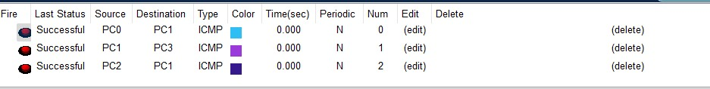

Conclusion : Using just switch we can successfully connect each using static IP allocation.The IP assigned must be different

